**JQUERY Tutorials**

**1.In case you write .text then message will display and in alert while passing variable don’t use (;) and (“”).(read operation)**

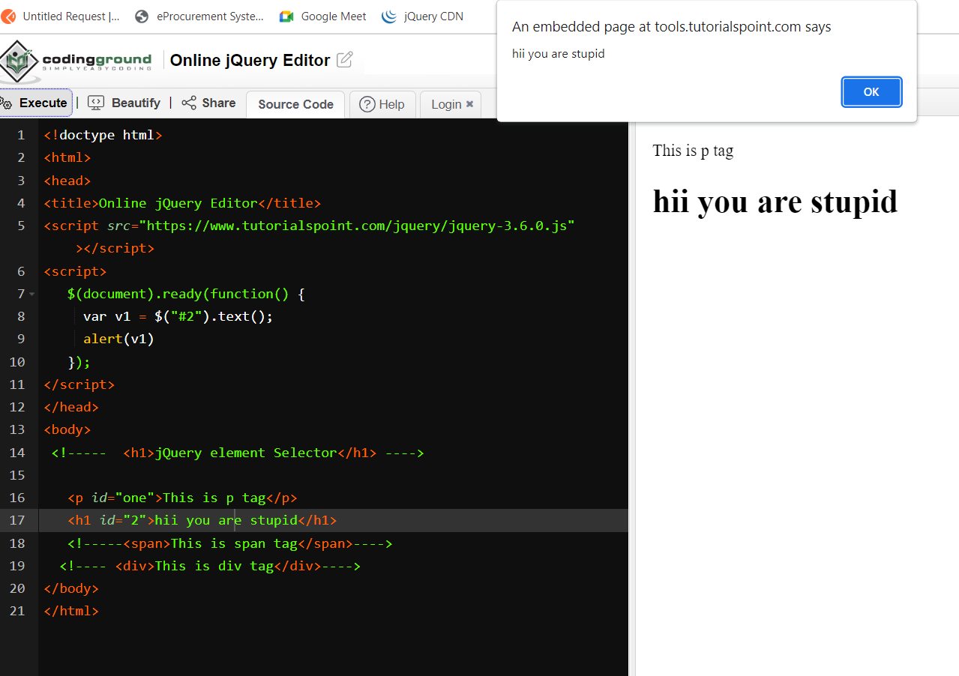

**2.In case you don’t write .text only object would be called.**

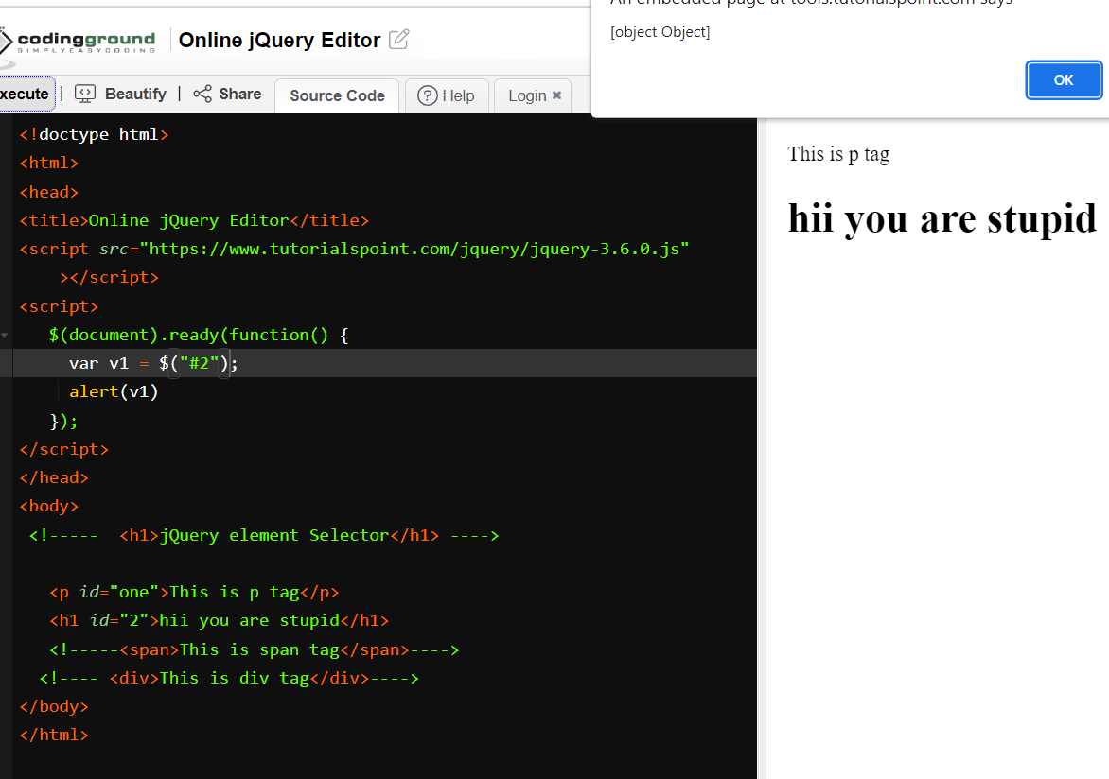

**3.In case you want to print a message in through .text() so with alert this pop up will show**

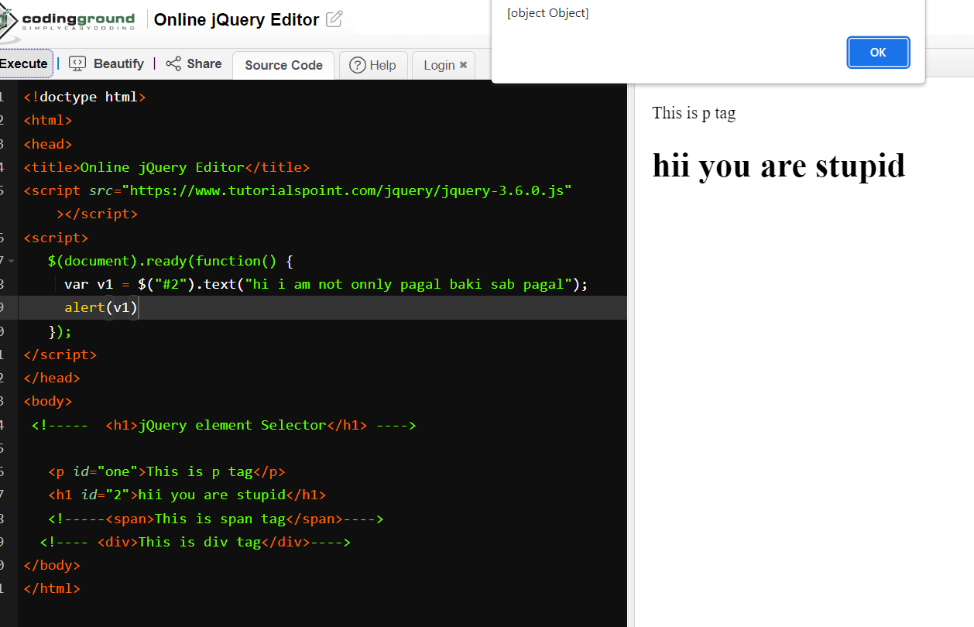

**3.In case you want to print a message in through .text() so with alert this pop up will not show instead message will print.(write operation)**

**4. way to acess of class**

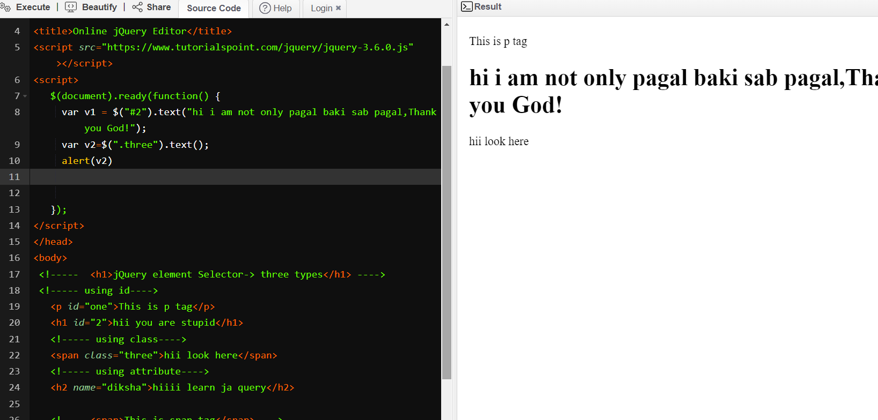

5. **Way to access of attribute**

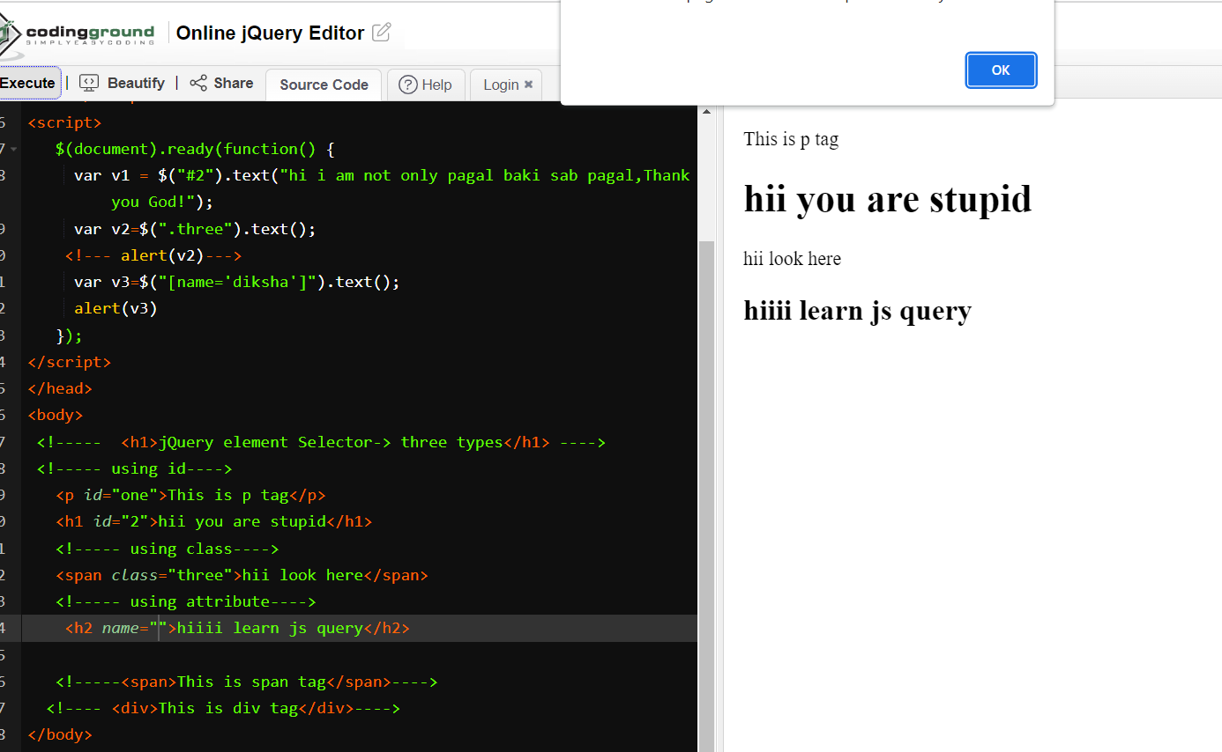

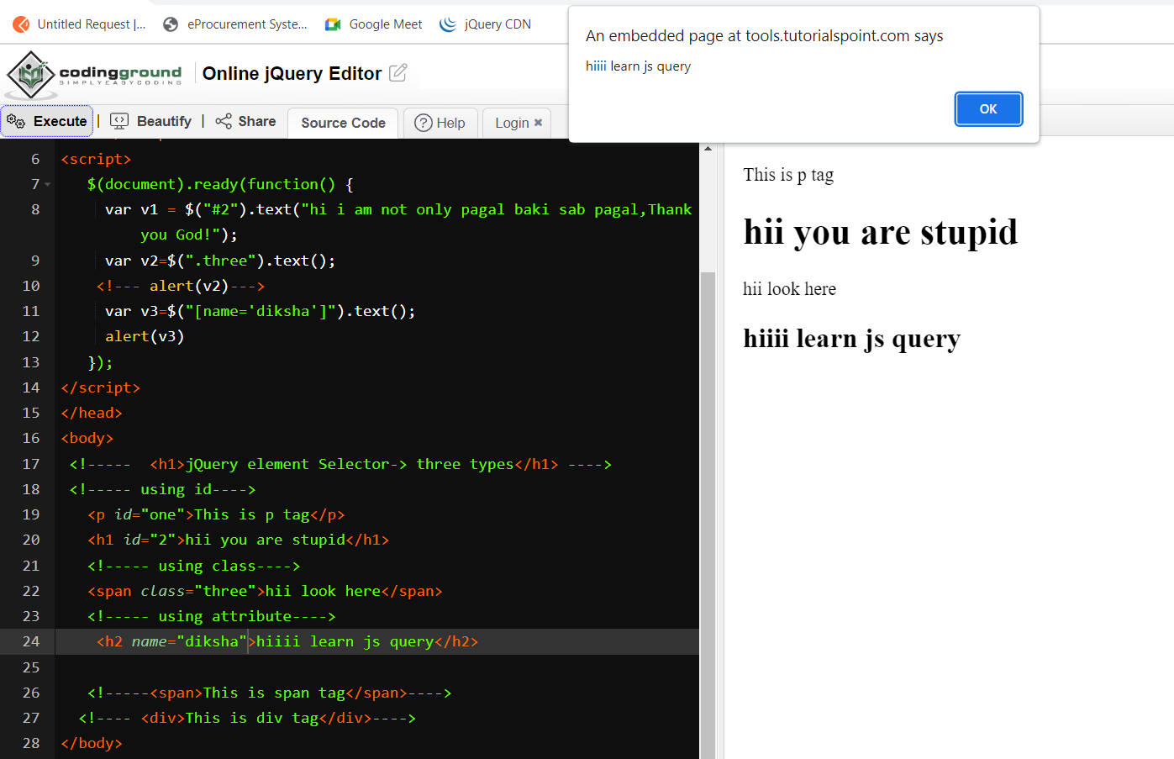

<!doctype html>

<html>

<head>

<title>Online jQuery Editor</title>

<script src="https://www.tutorialspoint.com/jquery/jquery-3.6.0.js"></script>

<script>

$(document).ready(function() {

var v1 = $("#2").text("hi i am not only pagal baki sab pagal,Thank you God!");

<!--here text is used to write the message->

var v2=$(".three").text();

<!--- alert(v2)--->

<!--.text() used to read the message->

var v3=$("[name='diksha']").text();

alert(v3)

});

</script>

</head>

<body>

<!----- <h1>jQuery element Selector-> three types</h1> ---->

<!----- using id---->

<p id="one">This is p tag</p>

<h1 id="2">hii you are stupid</h1>

<!----- using class---->

<span class="three">hii look here</span>

<!----- using attribute---->

<h2 name="diksha">hiiii learn js query</h2>

<!-----<span>This is span tag</span>---->

<!---- <div>This is div tag</div>---->

</body>

</html>

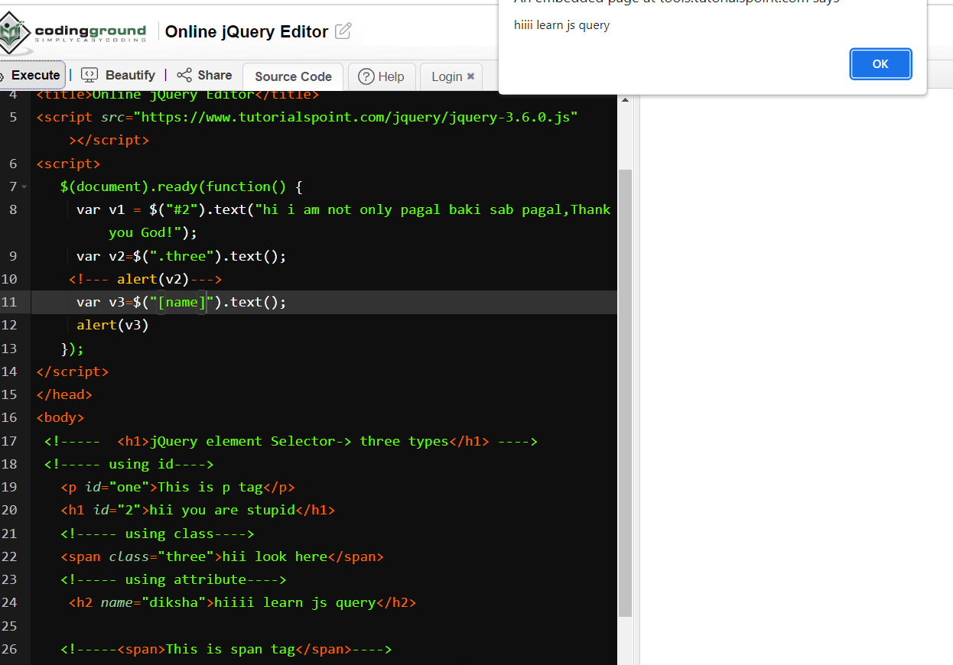

<!doctype html>

<html>

<head>

   <title>Online jQuery Editor</title>

   <script src="https://www.tutorialspoint.com/jquery/jquery-3.6.0.js"></script>

   <script>

      $(document).ready(function() {

$("#one").click(function(){

    alert("hello fiends:click event");

   });

   <input type="radio" name="gen" value="male">   </script>

</head>

<body>

   <h1>jQuery element Selector</h1>

   <p id="one">This is p tag</p>

   <input type="text" name="username" id="uname">

</body>

</html>